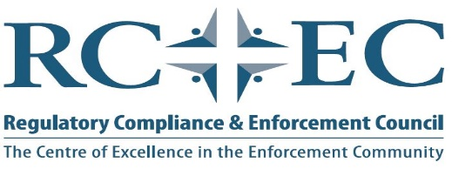

2022 Notice of Annual General Meeting of the Regulatory Compliance & Enforcement Council

On behalf of the Regulatory Compliance & Enforcement Council (RCEC) I wish to advise you of the upcoming Annual General Meeting to be held in a virtual setting on Tuesday, June 21, 2022 at 11:30 a.m. EST. Zoom meeting details are attached to this notice sent out via email to all members.
As per Article 12.1(d) of the RCEC Bylaws state “Notice stating the date, hour, place of meeting and the general nature of the business to be transacted shall be given to the membership of the Council at least twenty (20) days prior to the date of such meeting.”
The agenda will include:
- Presentation by Deric RAMM of the Alcohol and Gaming Commission of Ontario on Anti-Money Laundering,
- Welcome and introductions of those in attendance,
- State of the union and financial reports,
- Education and training report,
- Board vacancies and election of board members,
  - There are currently 7 of the 9 board positions that are up for election
- Membership report,
- Other items as identified
The current and revised By-Laws dated June 13, 2019, Article 6.2 dealing with elections and rotation state:
- Active members duly nominated shall be elected to the vacant positions on the board by ballot or acclamation. Each Director shall hold office for a term of two (2) years or until his or her successor shall have been duly elected.
- Nominations should be received by the Board prior to the date of the Annual General Meeting.
  - Nominations may be allowed, at the discretion of the Board, during the Annual General Meeting, but must be prior to the commencement of the election.
- No more that two (2) individuals from any one investigative body may be on the Board of Directors at any time.”

Below is the link to the RCEC web page for further information.
https://www.rc-ec.ca
The RCEC is looking to increase membership within the Municipal, Provincial and Federal environment and your assistance in advancing our cause would be appreciated. If you have colleagues who may be interested in the RCEC they may review our web site and will find the link to the application form.
If you have a submission for someone as a Board Member, I ask that you confirm they are willing to stand and when done so, submit their name and particulars to the undersigned via return email. We ask that you submit this where possible seven (7) days prior to the Annual General Meeting for distribution to the Board of Directors.
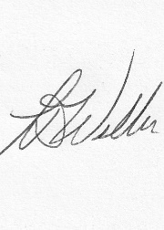
Terry Weller
Secretary to the Regulatory Compliance and Enforcement Council (RCEC)

