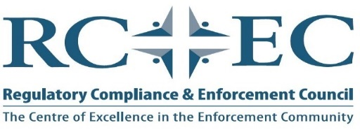
2020 Training Calendar (updated May 24, 2020)
Course title | Anticipated Date | Duration | Audience | Location | Description
Confrontation Management | April 9, 2020  TBD due to Coronavirus concerns | 1 | Variety of personnel where confrontation may become an issue | TBD | Program discusses the communication process, controlling anxiety and de-escalating techniques. There is a group exercise and physically acting out scenarios.
Introductory tactical use of the internet | May 11, 2020  TBD due to coronavirus concerns | 1 day | Investigators and enforcement personnel | Offices of FP Canada, 375 University Ave., 4th floor, Toronto | Candidates introduced to reactive vs. proactive use of the internet and where to go to find the desired information
Crossing the Rubicon | June 9, 2020  TBD due to coronavirus concerns | 1 | Enforcement and compliance personnel | Offices of the AGCO, 90 Sheppard Ave. E., Toronto | This technical program identifies regulatory actions, criminal actions, and when a regulatory action turns into a criminal investigation. There will be discussions on relevant case law and where we stand today.
Regulatory Compliance Fundamentals | October 26, 2020 | 5 days | New Investigators, Inspectors, & compliance staff | Offices of The Alcohol and Gaming Commission, 90 Sheppard Ave. E., Toronto | 40-hour Introduction training program specifically designed for enforcement personnel
Advanced Interviewing and Note Taking | Late Fall 2020 | 2 days | Seasoned enforcement personnel and anyone other personnel expected to testify in court | TBD | This advanced course is designed for personnel that have testified in court and wish to improve their overall skills in the courtroom. Designed for Investigators, Inspectors, Compliance personnel, and anyone else required to testify in course. This course is not designed for expert witnesses. The participants will be assigned a case where from which they will prepare notes and complete interviews. They will testify at a mock trial in a court room setting. Their testimony will be recorded and supplied to the candidate.
Crossing The Rubicon | December 2, 2020 | 1 day | Enforcement and compliance personnel | Offices of the AGCO, 90 Sheppard Ave. E., Toronto | This technical program identifies regulatory actions, criminal actions, and when a regulatory action turns into a criminal investigation. There will be discussions on relevant case law and where we stand today.

Please contact the RCEC for exclusive delivery of these programs

